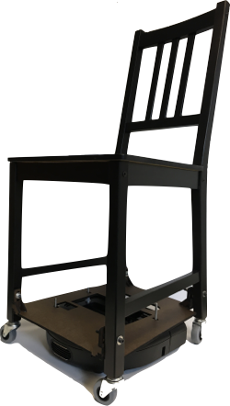**Overview**

The main design objective of Chairbot was to have an easily manufacturable and replicable system by repurposing over-the-counter goods. For our drive system, we used a Neato; for the chair, we used Ikea’s Stefan chair. We will be using a Raspberry Pi to interface with the Neato and send commands from a Linux system (computer or Pi) reading inputs from a Playstation 3 controller. Software is available on github. To assemble the chair, you will need access to a laser-cutter and drill press.

**Required Materials**

**Mechanical Needs**

|  |  |
| --- | --- |
| Neato | 1 |
| Ikea Stefan chair | 1 |
| Threaded Inserts (5/16"-18 x 0.954") | 4 |
| Casters | 4 |
| Threaded rods (1/4"-20 x 5”) | 4 |
| Washers (1/4”) | 14 |
| Screws (1/4"-20 x 2.5”) | 16 |
| Nuts (1/4”-20) | 8 |

**Electrical Needs**

|  |  |
| --- | --- |
| Raspberry Pi | 2 (or 1 + a linux computer) |
| Dualshock 3 Controller | 1 |

**Software Needs**

For the Raspberry Pi interfacing with the Neato

https://github.com/CDR-IxD/node-neato

For the Raspberry Pi interfacing with the Playstation 3 controller

https://github.com/CDR-IxD/node-neato-ps3controller

**Assembly Directions**

1. Disassemble the Neato

https://www.youtube.com/watch?v=PQg0CTiWReE&t=207s

1. Drill 0.263” holes into the following locations

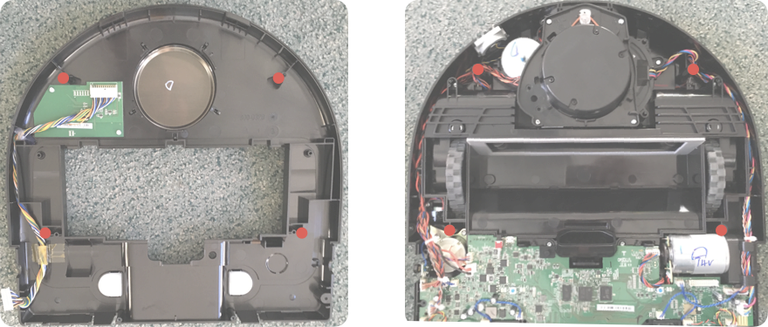

1. Reassemble the Neato
2. Laser-cut the following files on 0.25” thick duron
3. Assemble the duron platform

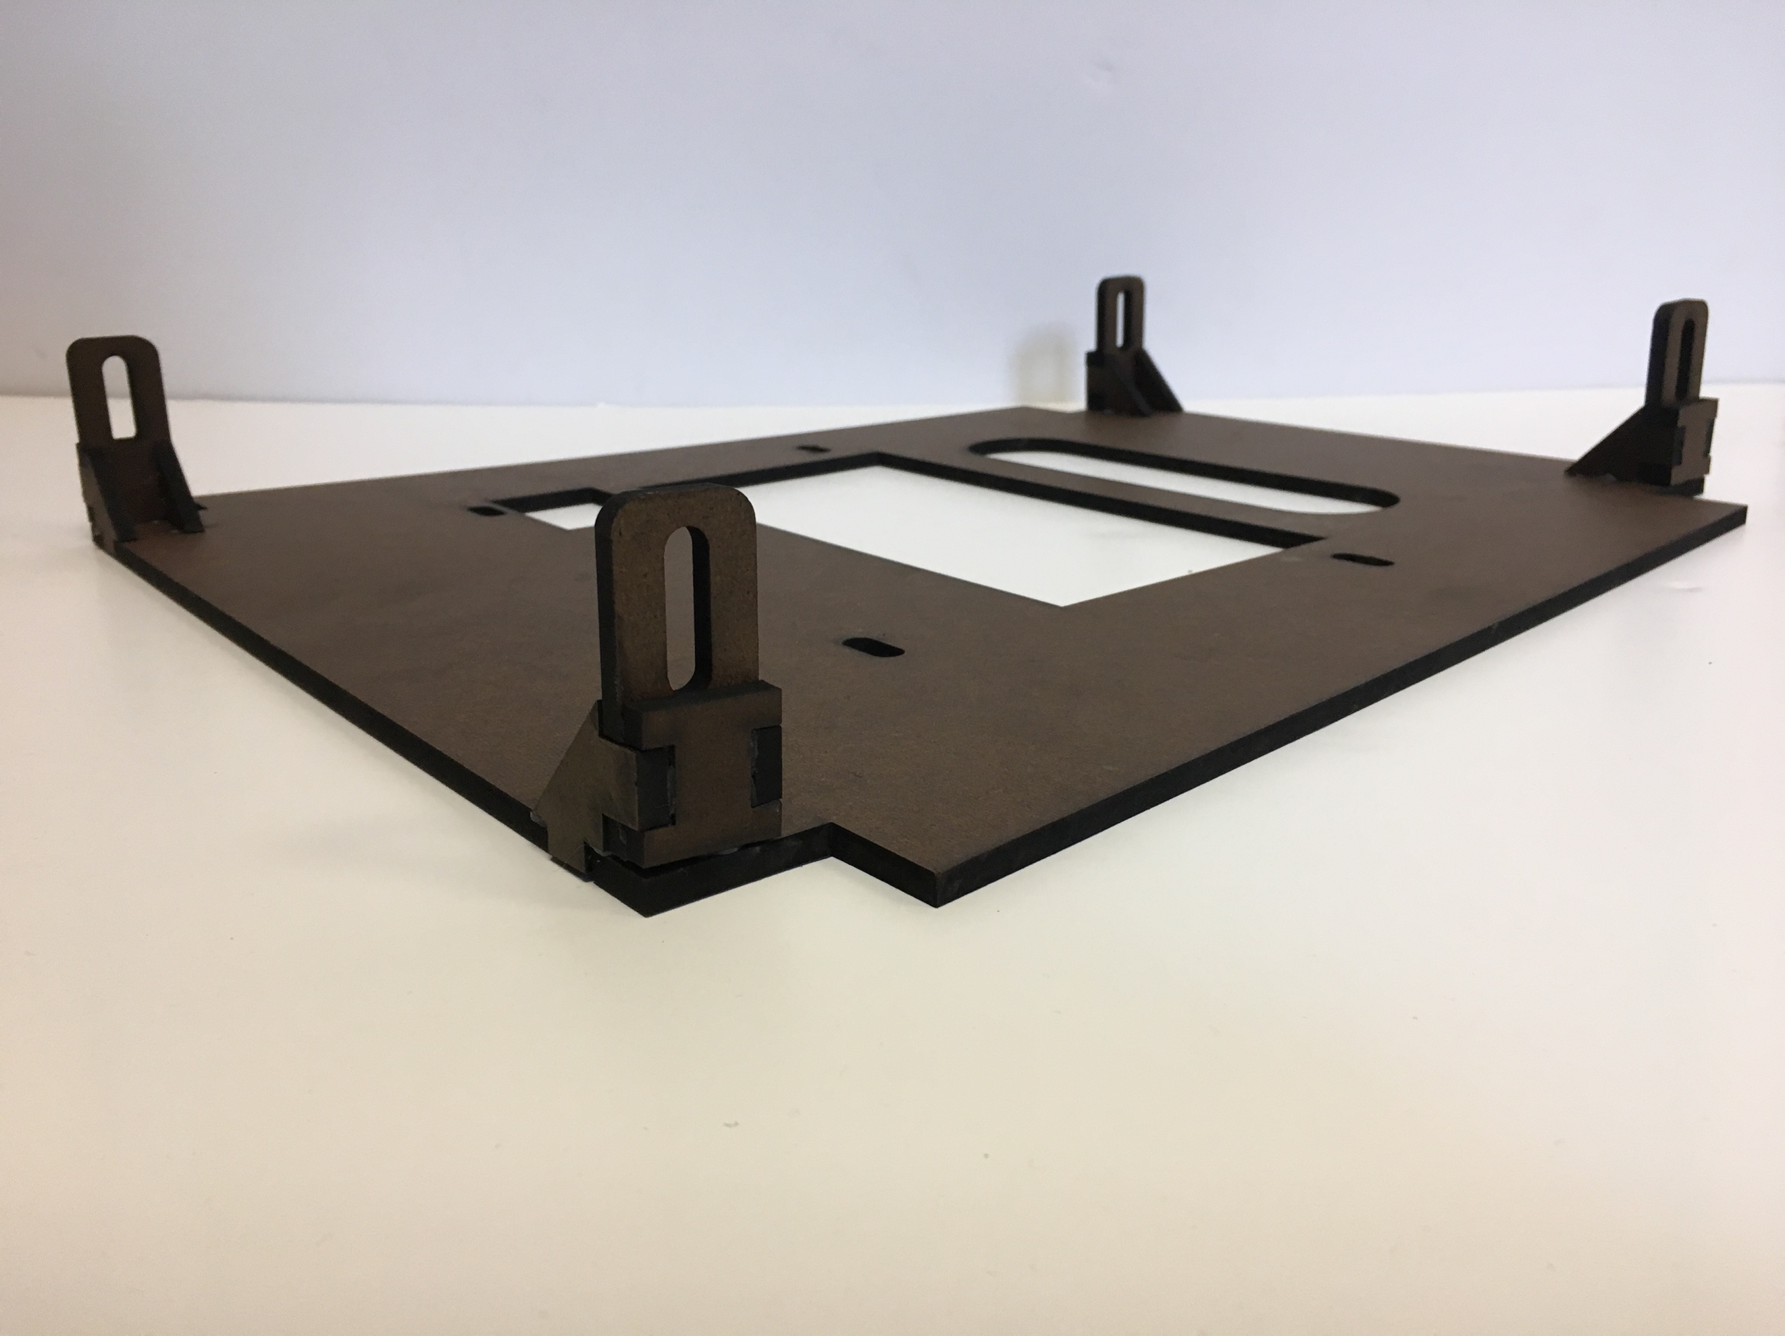

1. Drill holes into the bottom of the chair legs
2. Insert the threaded inserts
3. Use the template to mark hole locations on the chair legs. The template’s edges should datum with the chair’s front leg.
4. Drill holes into the chair legs
5. Assemble the chair following Ikea instructions

http://www.ikea.com/ms/en_US/customer_service/assembly/S/S10115072.pdf

1. Place the threaded rods through the holes, using the washers and screws to retain the threaded rod and adjust the duron platform height. The duron should sit on four nuts and the lidar.

Notice: The holes closest to the Lidar have 1 washer and 3 nuts, while the holes further have 4 washers and 3 nuts.

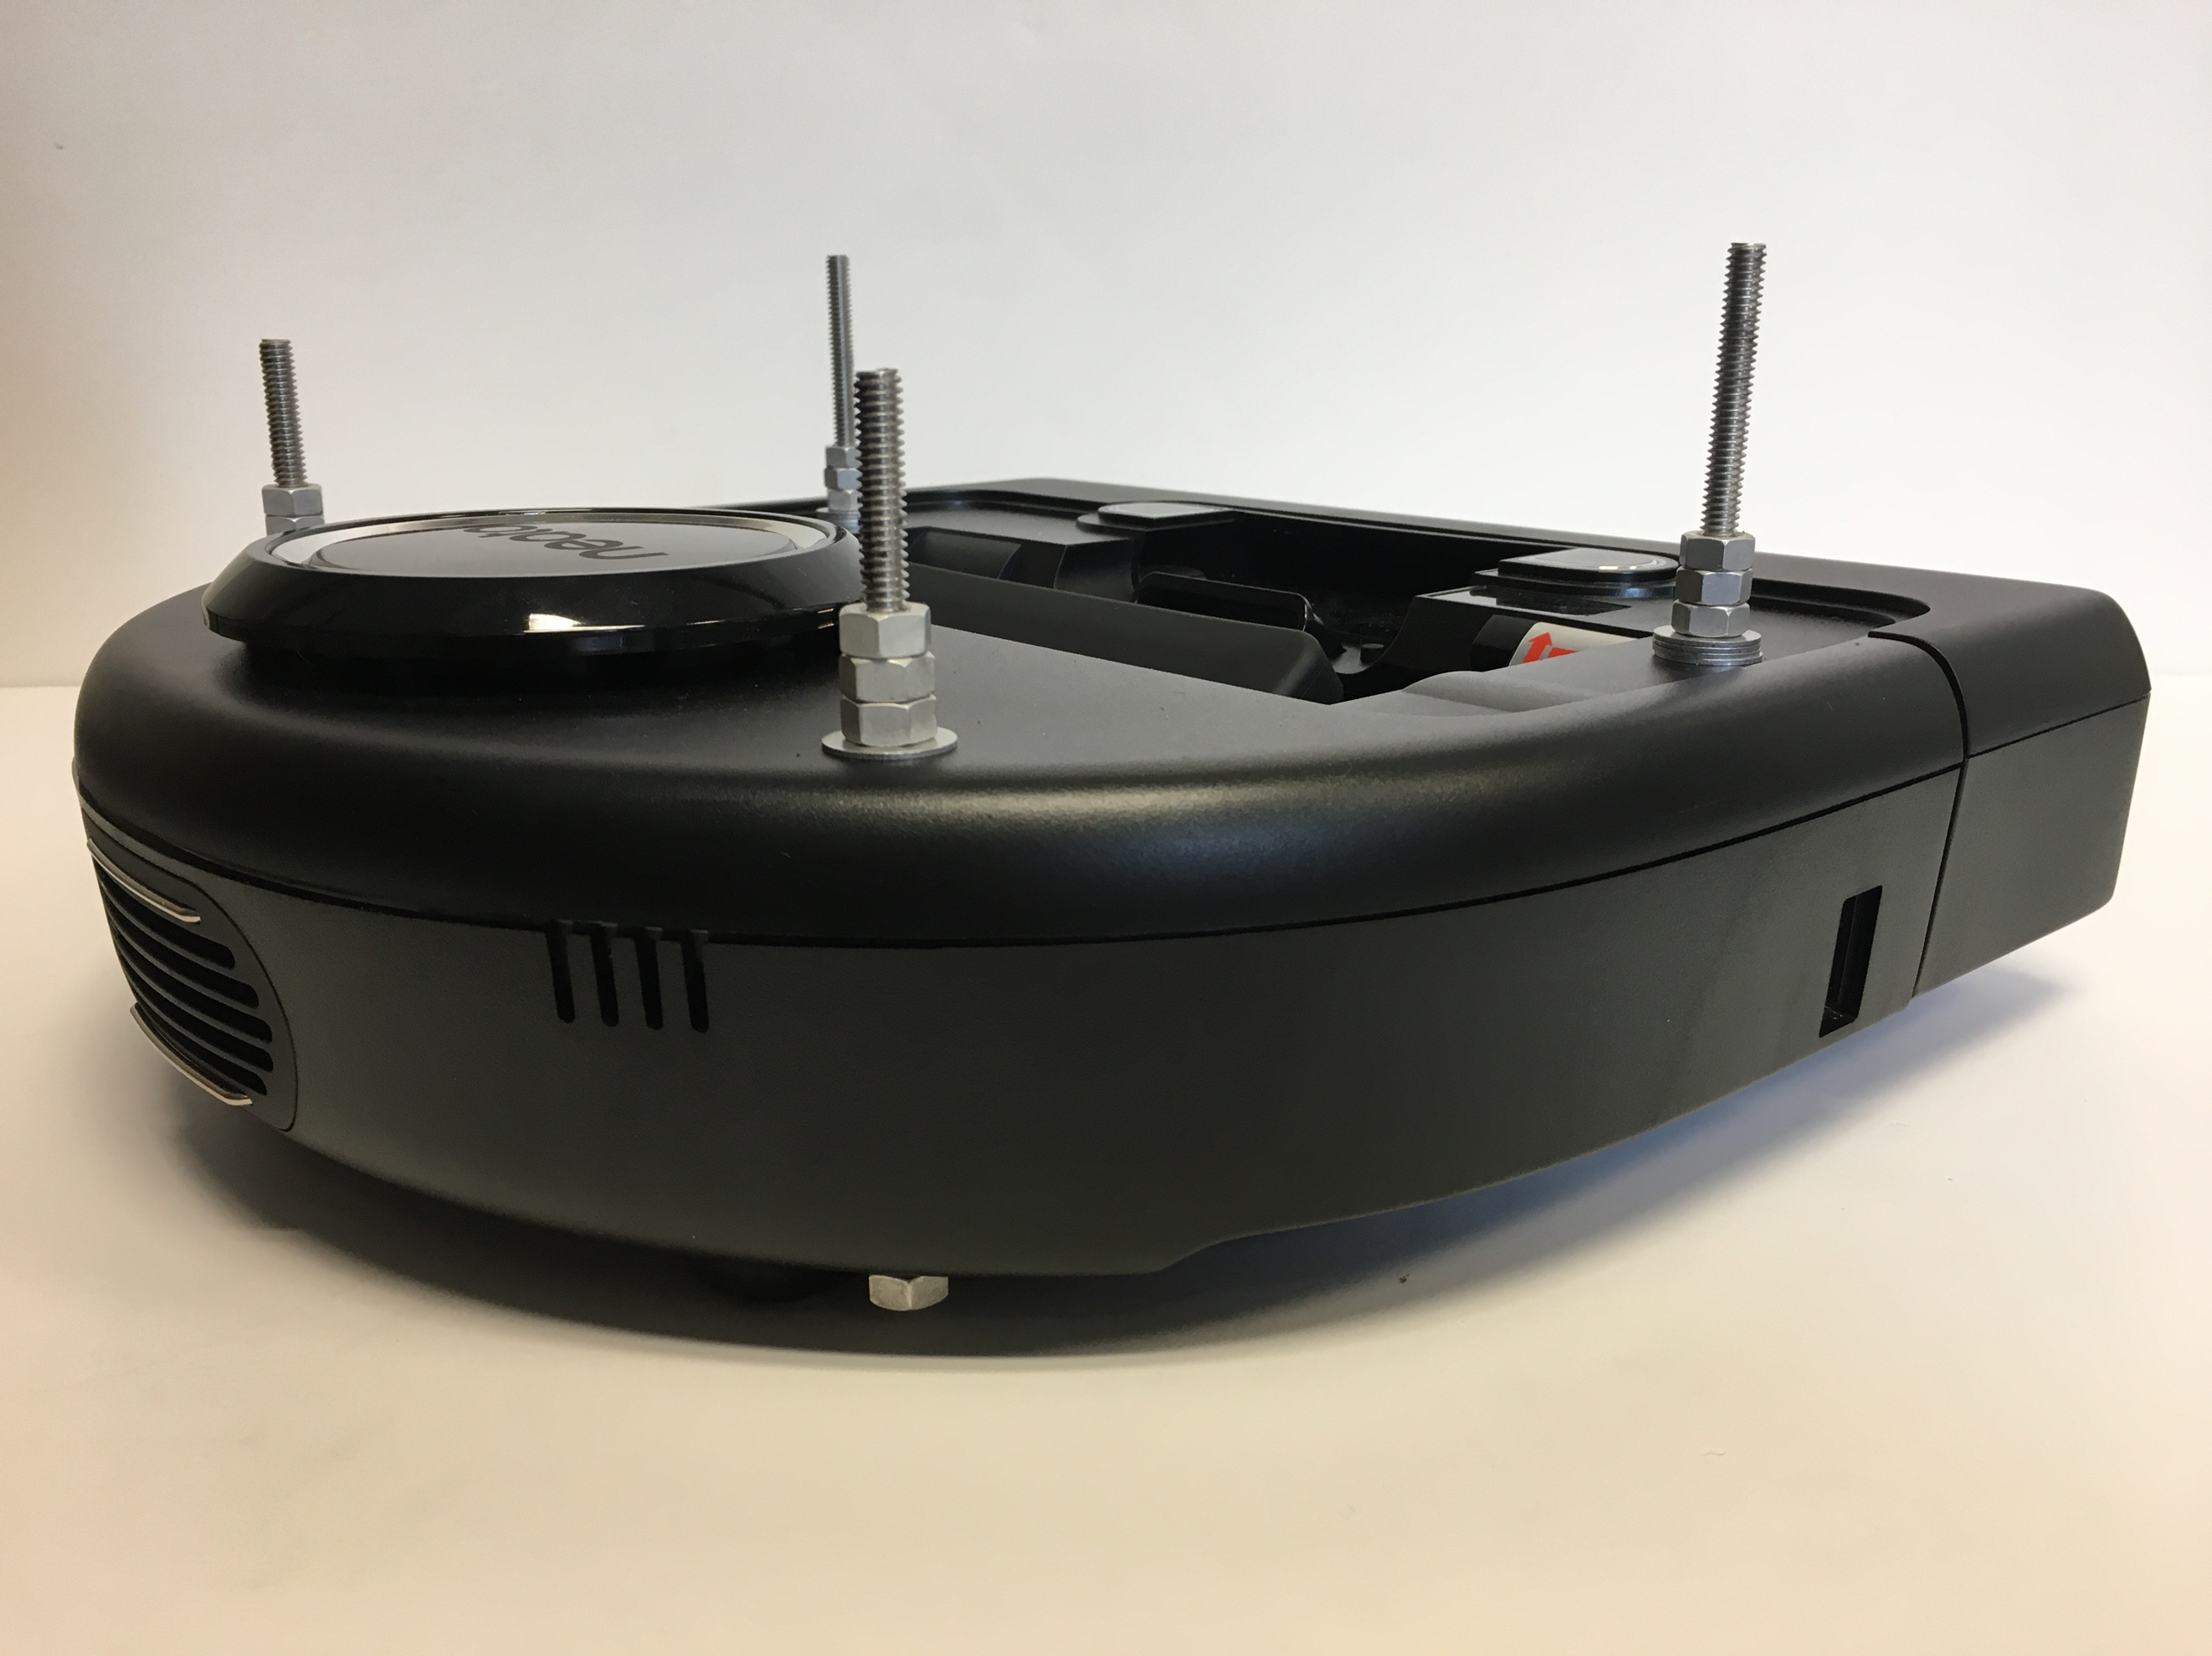

1. Mount everything

